Open Excel file: TwoMode_table_NODEXL_CLEANED

Activate tab: table

Filter for appropriate year using column: Submitted Date

Copy filtered data (including headings) into a new sheet titled for the data grant year, e.g., 2004

Sort the new sheet data by Grant ID in reverse order (Z to a) – this is needed because NODEXL will reverse the order of the lines as it imports the data from this sheet

Make sure the excel file is open and the newly created sheet is selected

Open a new NODEXL file

Select ‘NodeXL/Import/From Open Workbook…’

In the import screen, make sure the correct input workbook is selected and ‘Grant ID’ and ‘Investigator’ are specified as Vertex 1 and 2 respectively, then select the edge columns and the Vertex 1 and 2 attributes as shown below:

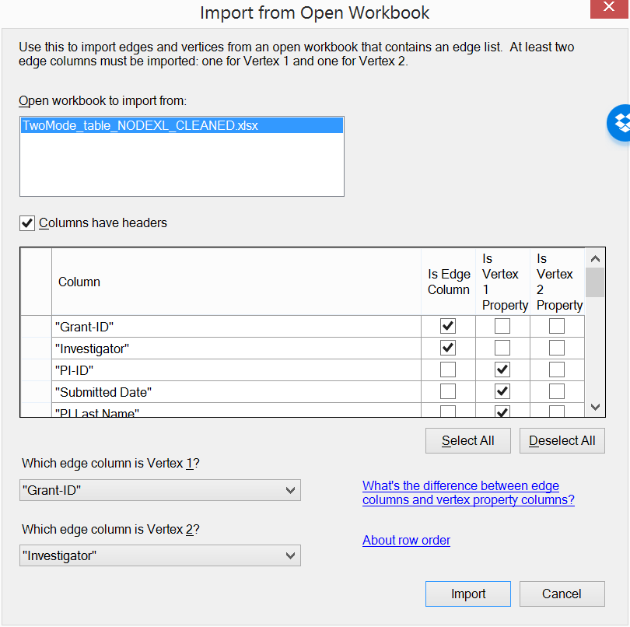

Then select the rest of the columns as Vertex 1 attributes except for Investigator Last Name, First Name, and Dept which must be selected as Vertex 2 (Investigator) attributes.

Select ‘Import’ and wait until the data is imported into NodeXL (into the Edges and Vertices tabs).

Note that no ‘Edge’ attributes can be imported using the above method. It is useful, however, to include edge attributes that can be used to create graphs and conduct analyses of different subsets of data so it is recommended that we also include all the attributes in the Edges worksheet. To do that:

Sort the data in the new year worksheet from A to Z (same order as the data in the NodeXL file) and copy all the data except the first two columns (including headings) into the nodeXL file ‘Edges’ sheet in ‘Other Columns’ (starting at column ‘O’ and making sure column headings are in row 2).

Because vertices in our datasets can be either grants or investigators, we need to create an attribute that allows us to discriminate between the two types of vertices. We can do so by sorting the vertices sheet by the ‘Vertex’ column and then adding a new vertex attribute column with a 1 for all grant vertices and a 0 for all investigator vertices. This numeric attribute will serve, for example, to create different colors or shapes for grants and investigators in the graph we generate.

Save both the new NodeXL file using the format ‘2-Mode SNA <year>’ and the TwoMode_table_NODEXL_CLEANED file with the new tab created.

Now your nodeXL file for the new year is ready for analysis.

An example of a nodeXL file already created is 2-Mode SNA 2004.